**Name:** Anushka H. Nevgi

**Roll number: A**31

**Course:** Advanced Database Management System1

**Guided by:** Prof. Mrunal A. Deshpande

**Problem Statement:** In emergency situations, finding a blood donor quickly can be a matter of life and death. This project aims to maintain a structured, accessible database of registered donors, blood requests, and a matching mechanism that enables hospitals or individuals to efficiently find available blood donors based on location, blood group, and last donation date. The project is implemented using PL/SQL with procedures, triggers, and reporting queries to simulate real-time tracking and allocation.

**ER diagram:**

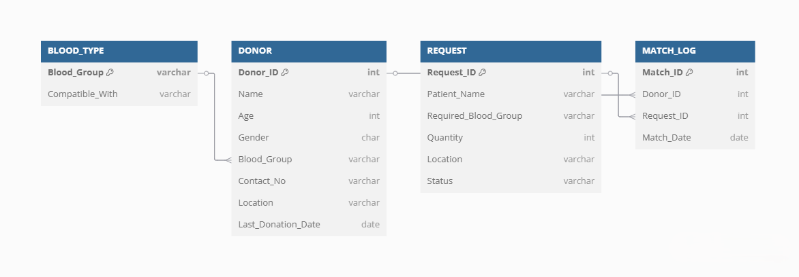

**Entity-Relationship Description:**

DONOR (Donor_ID, Name, Age, Gender, Blood_Group, Contact_No, Location, Last_Donation_Date)  
BLOOD_TYPE (Blood_Group, Compatible_With)  
REQUEST (Request_ID, Patient_Name, Required_Blood_Group, Quantity, Location, Status)  
MATCH_LOG (Match_ID, Donor_ID, Request_ID, Match_Date)

**Creating tables:**

CREATE TABLE DONOR (

    Donor_ID NUMBER PRIMARY KEY,

    Name VARCHAR2(50),

    Age NUMBER,

    Gender VARCHAR2(10),

    Blood_Group VARCHAR2(5),

    Contact_No VARCHAR2(15),

    Location VARCHAR2(50),

    Last_Donation_Date DATE

);



CREATE TABLE BLOOD_TYPE (

    Blood_Group VARCHAR2(5),

    Compatible_With VARCHAR2(5)

);



CREATE TABLE REQUEST (

    Request_ID NUMBER PRIMARY KEY,

    Patient_Name VARCHAR2(50),

    Required_Blood_Group VARCHAR2(5),

    Quantity NUMBER,

    Location VARCHAR2(50),

    Status VARCHAR2(20)

);



CREATE TABLE MATCH_LOG (

    Match_ID NUMBER PRIMARY KEY,

    Donor_ID NUMBER,

    Request_ID NUMBER,

    Match_Date DATE,

    FOREIGN KEY (Donor_ID) REFERENCES DONOR(Donor_ID),

    FOREIGN KEY (Request_ID) REFERENCES REQUEST(Request_ID)

);

**Inserting data into the tables:**

-- Sample Donors

INSERT INTO DONOR VALUES (1, 'Rahul', 25, 'Male', 'A+', '9999999999', 'Pune', TO_DATE('2024-12-01','YYYY-MM-DD'));

INSERT INTO DONOR VALUES (2, 'Sneha', 30, 'Female', 'O-', '8888888888', 'Pune', TO_DATE('2025-03-01','YYYY-MM-DD'));

-- Blood Type Compatibility

INSERT INTO BLOOD_TYPE VALUES ('A+', 'A+');

INSERT INTO BLOOD_TYPE VALUES ('A+', 'O+');

INSERT INTO BLOOD_TYPE VALUES ('O-', 'O-');

-- Sample Request

INSERT INTO REQUEST VALUES (101, 'Ravi Patil', 'A+', 1, 'Pune', 'Pending');



**Creating various procedures and implementing them:**

1. **Donor Details Update**:

CREATE OR REPLACE PROCEDURE Update_Donor_Details(p_donor_id NUMBER, p_new_location VARCHAR2, p_new_last_donation_date DATE) AS

BEGIN

-- Update the donor's location and last donation date

UPDATE DONOR

SET Location = p_new_location,

Last_Donation_Date = p_new_last_donation_date

WHERE Donor_ID = p_donor_id;

-- Commit the changes

COMMIT;

-- Print a success message

DBMS_OUTPUT.PUT_LINE('Donor ' || p_donor_id || ' details updated successfully.');

END;

/



EXEC Update_Donor_Details(1, 'Mumbai', TO_DATE('2025-05-01', 'YYYY-MM-DD'));

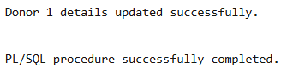

2. **Checking Available Donors for a Specific Blood Group**:

CREATE OR REPLACE PROCEDURE List_Available_Donors(p_blood_group VARCHAR2, p_location VARCHAR2) AS

BEGIN

    FOR donor IN (

        SELECT Donor_ID, Name, Blood_Group, Location, Last_Donation_Date

        FROM DONOR

        WHERE Blood_Group = p_blood_group

          AND Location = p_location

          AND Last_Donation_Date <= SYSDATE - 90  -- Donors who haven't donated in the last 90 days

    ) LOOP

        -- Display donor details

        DBMS_OUTPUT.PUT_LINE('Donor ID: ' || donor.Donor_ID || ' Name: ' || donor.Name || ' Blood Group: ' || donor.Blood_Group || ' Location: ' || donor.Location || ' Last Donation: ' || donor.Last_Donation_Date);

    END LOOP;

END;

/



EXEC List_Available_Donors('A+', 'Pune');



3. **Check Status of a Blood Request**:

CREATE OR REPLACE PROCEDURE Check_Request_Status(p_request_id NUMBER) AS

    v_status VARCHAR2(20);

BEGIN

    -- Fetch the status of the given request ID

    SELECT Status INTO v_status

    FROM REQUEST

    WHERE Request_ID = p_request_id;

    -- Display the request status

    DBMS_OUTPUT.PUT_LINE('Request Status for Request_ID ' || p_request_id || ': ' || v_status);

EXCEPTION

    WHEN NO_DATA_FOUND THEN

        DBMS_OUTPUT.PUT_LINE('No request found with ID ' || p_request_id);

END;

/



EXEC Check_Request_Status(102);

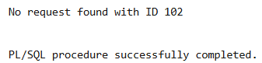

4. **Mark a Blood Request as Fulfilled**:

CREATE OR REPLACE PROCEDURE Mark_Request_Fulfilled(p_request_id NUMBER) AS

BEGIN

-- Update the request status to 'Fulfilled'

UPDATE REQUEST

SET Status = 'Fulfilled'

WHERE Request_ID = p_request_id;

-- Commit the changes

COMMIT;

-- Print success message

DBMS_OUTPUT.PUT_LINE('Request ID ' || p_request_id || ' has been marked as Fulfilled.');

END;

/



EXEC Mark_Request_Fulfilled(102);

